Dear Parent/Guardian:

The North Carolina Department of Public Instruction (NCDPI) has a partnership with ACT, a not-for-profit organization that provides educational assessment, research, information, and program management services. In North Carolina, all tenth graders take the PreACT. This assessment measures what students have learned in their courses and helps educators identify the information that students still need to learn to succeed in college or a career. Your child is scheduled for the makeup PreACT on April 27th, 2021.

The PreACT simulates the ACT testing experience by providing students early exposure to ACT test-quality questions. The PreACT is reported on the same 1–36 score scale as the ACT, but PreACT has a maximum score of 35. The PreACT also provides a predicted ACT composite score range.

The PreACT assessment includes four multiple-choice tests: English, math, reading, and science. The PreACT is designed to help parents and educators identify areas where students may need additional academic support or remediation. The PreACT can also help to initiate strategic conversations between parents and schools regarding dual enrollment decisions, identifying curriculum gaps, implementing interventions on behalf of students, and choosing Advanced Placement classes.

If possible, please bring two sharpened number 2 pencils (no mechanical pencils or pens) and a scientific or graphing calculator on the day of the exam. Students should arrive no later than 9:15am. Doors will open at 9:00am. All students will have to go through the check-in process (assentation form, temperature check, etc.). The test will begin at 10:00am SHARP. Students will NOT be permitted to enter the exam site after the start time. Breakfast and lunch will be provided.

If you have questions or concerns about the upcoming PreACT administration at Page High School, please contact Dr. Mutawally at mutawas@gcsnc.com or at (336) 370-8200.

Sincerely,

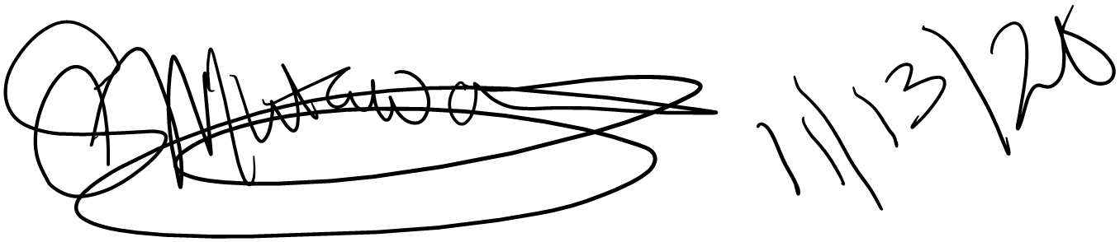
Sabreen Mutawally, PhD
Assistant Principal

