FIFTH GRADE LITERACY STANDARDS
RI.5.7 Draw on information from multiple print or digital sources, demonstrating the ability to locate an answer to a question or to solve a problem efficiently.
RL.5.7 Analyze how visual and multimedia elements contribute to the meaning, tone, or aesthetics of a text.
W.5.3 Write narratives to develop real or imagined experiences or events using effective technique, descriptive details, and clear event sequences.
__ __ __ __ __ __ __
What is important to you? ( what matters a lot?)
Friends? Future career?
Job? The environment?
Music? Celebrities?
Pets? Artistic ability?
Fashion? Faith?
Athletic ability? Cars? or something else?
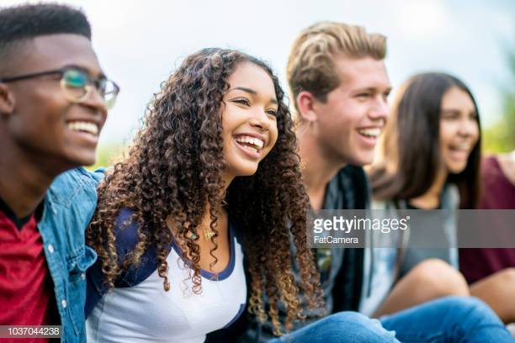 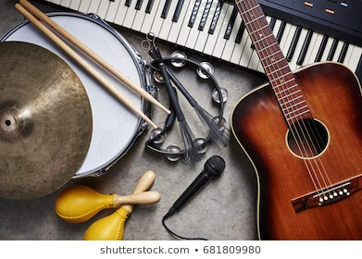
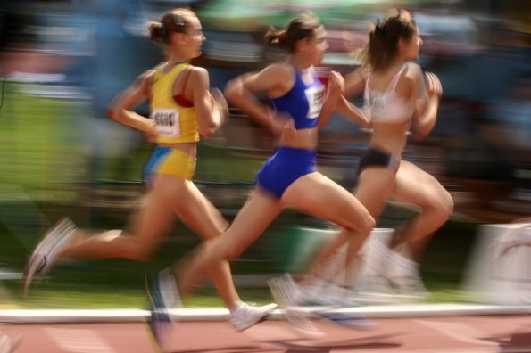

1. Make a list of at least TWO things that are most important to you.
2. Write each one in its own circle, then draw spokes going out from each circle with words that describe it more completely.
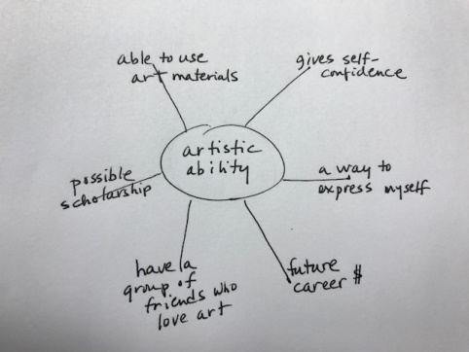
- In your sketchbook or on sketch paper, create small doodle drawings/rough icons that could represent your inner circle word and the words on the spokes. Try to “keep your pencil moving” (no erasing yet :-) to capture quick mental ideas. No perfect drawings needed!
ROUGH SKETCHES LIKE THESE BELOW IS WHAT YOU ARE GOING FOR:
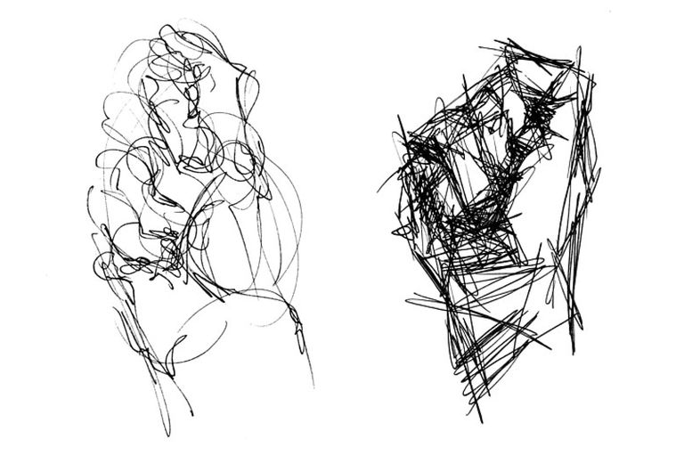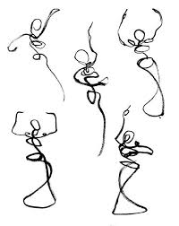
4. After you have created about four rough sketches, look in magazines that are okay to cut up. CHECK WITH YOU PARENTS BEFORE CUTTING A MAGAZINE. If it’s okay to cut, find at least four magazine pictures that could express some of your words or ideas in the spokes.
5. Paste them into your sketchbook or on white paper.

6. Now, create three new drawings that visually combine your first rough sketches and the pasted image. Suggestions: try drawing one of your original rough sketches on top of a magazine image…..or reverse it so that you draw just a section of the magazine image onto one of your rough sketches. Basically, you are creating a new image by combining selected parts of two other images.
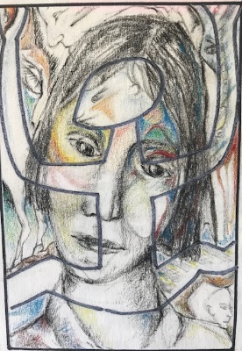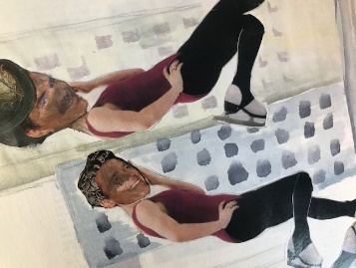
7. Select your favorite of your new combination drawings. Look carefully at all parts. Then make up a short story, at least six paragraphs, that tells us:
WHO are the characters in your story? (they can be people, animals,
or fantasy creatures)
WHAT will your characters be doing? (Are they going on a trip? Are they playing a game? Will they listen to music, and eat some food?....or anything else!)
WHEN will these things happen….or did they already happen in the past?
WHERE does the action take place? (outside….or inside a building…at school….in the park….at a store, etc.)
HOW did the action begin? What happened in the middle? How did it end? Describe the BME - -beginning, middle, and end
WHY did your characters do what they did? Why did the story unfold the way it does?

Be sure to use at least five words or phrases from your circle drawing with spokes, in # 2 above.

8. Now use any TWO of the websites below to research artists who express what is important to them.
As you look at each of your two sites, answer the following questions:
a) Find your favorite artist on this website. Give his or her name and tell where they are from. Then list three extra facts about this artist. Make a very small drawing of one of their artworks - - -it does NOT have to be perfect! Your drawing should be about 4 inches x 5 inches.
b) Now find an artist whose work you do NOT like. Tell us their name and where they are from. List several reasons why you do not like it. Make another small drawing of this not-favorite artwork

HERE ARE THE WEBSITES TO CHOOSE ANY TWO FROM:
--“TEN CONTEMPORARY AFRICAN ARTISTS YOU DON’T KNOW BUT SHOULD”
https://www.huffpost.com/entry/contemporary-african-artists_n_56255056e4b02f6a900d59a6
_ _ _ _ _ _ _ _
--THIS SITE IS OF CONTEMPORARY ARTISTS WHO USE PETS AND ANIMALS AS SUBJECT MATTER (no disturbing images here)
https://animalinstances.com/the-contemporary-fine-artists-representation-of-the-animal/
_ _ _ _ _ _ _
--THIS IS AN INTERESTING SITE THAT SHOWS PHOTOREALISTIC PAINTINGS
https://www.invaluable.com/blog/photorealism/
_ _ _ _ _ _ _ _ _ _
--THIS IS A BEAUTIFUL SITE WITH EXTREMELY FASCINATING ART CONCERNING THE ENVIRONMENT
https://www.huffpost.com/entry/environmental-art_n_5585288

