ART, SCIENCE, AND MAGIC ! - - DALE CHIHULY

SCIENCE STANDARD – 3RD GRADE
3.P.2.3. Summarize changes that occur to the observable properties of materials when different degrees of heat are applied to them, such as melting ice or ice cream, boiling water or an egg, or freezing water.
SOCIAL STUDIES STANDARD – 3RD GRADE
3.C.1.2 Exemplify how various groups show artistic expression within the local and regional communities.
_ _ _ _ _ _

Show the youtube below, *after* showing questions 1-10 (next page) for students to find answers as they watch!

Shattering the Mold: Chihuly and the Science of Glassblowing, Part 1
https://www.youtube.com/watch?v=HV2pEZPy5lI

CHIHULY ACTIVITY SHEET Name_______________________
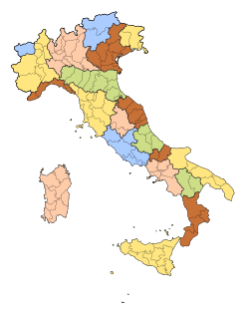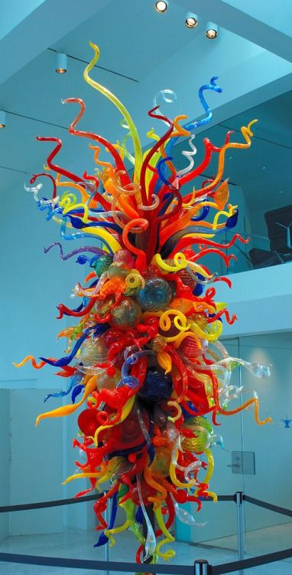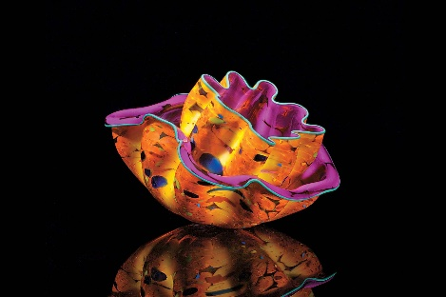

- DNA is the ____________ _____________ of life.
- Dale Chihuly was born in what year? ___________
- To earn money to continue his studies, Chihuly took a job as a ____________________ in what place? __________________
- Dale Chihuly and a bunch of his friends started an _________ ___________ on a _________ farm.
- The word “transparent” means __________________________
- Chihuly wears an eye patch because his eye was injured how?________________________________________________
- He learned that it is better to work with a __________________
- Where does glass come from?____________________________
- What are the three ingredients to create glass?
a) _________________________
b)__________________________
c)__________________________
- (extra credit)…..Look at the map at the top of this page. Where is this?
____________________________________________________________

(NOTE TO TEACHER: Answers to above questions are at the very end of this document.)

One of the most famous glass styles that Chihuly created is called the “Macchia”…..this is an Italian word which means “spot or stain”. The reason that Chihuly uses this term is that his glass sculptures in this style have spots or “stained” areas. (notice the spotted areas on these vases)

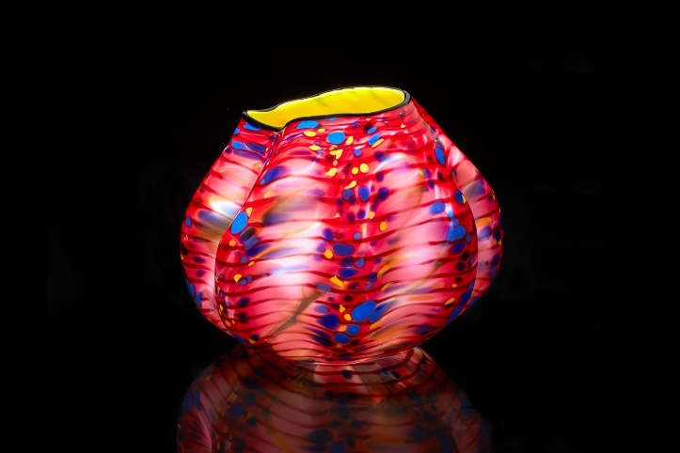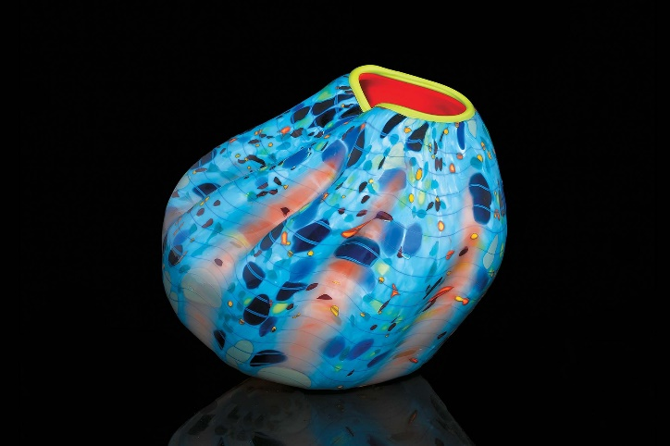

We will do a project now to create our own macchias!
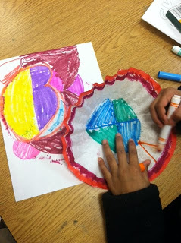 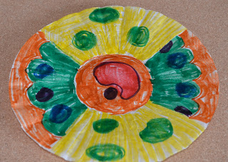
1. Use washable markers and create a design on a white coffee filter. Remember to put several “macchias” (spots & dots) in places on your design. Color all areas of your filter.
(markers must be washable – water soluble – to allow color bleeding later)

2. 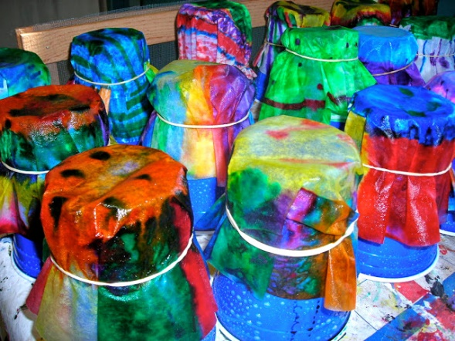 Slide your finished filter onto an inverted cup and
fasten with rubber band.

3. 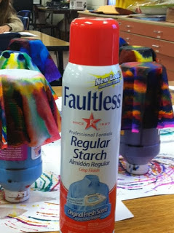 Let your teacher show you how to spray liquid
starch onto your inverted filter…..watch the magic as your colors bleed and blend !

4. 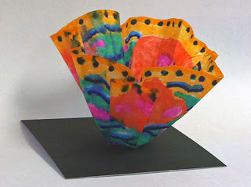 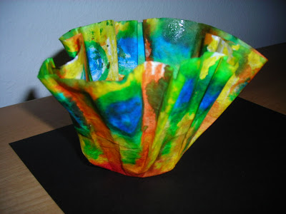
Last step: Once your macchia has dried, it will be shiny and beautiful, and you can glue it to a small piece of black cardstock or mat board to show it off.

5. Challenge: What do you think is the “mood” of Chihuly’s glass sculptures…meaning how do you think his artwork makes people feel?

___________________________________________________________________________

_ _ _ _ _ _ _
Teacher section only……answers to questions 1-10 on student Activity Sheet above
- Building block
- 1941
- Fisherman…….Alaska
- Art school….tree
- Able to “see through it”
- In a car accident
- Team
- Sand
- Silica……sodium carbonate……lime or limestone (and then is HEATED)
- The country of Italy

