UNUSUAL ANIMAL STRUCTURES -
ELEPHANTS AND GIRAFFES

4.L.1.2 Explain how animals meet their needs by using behaviors in response to information received from the environment.

WHY DO ELEPHANTS HAVE SUCH LONG TRUNKS?

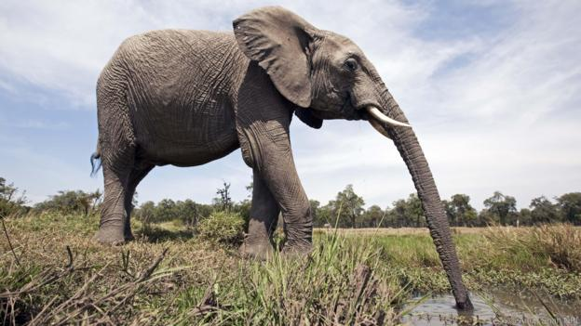

The elephant's trunk is very important for it to eat enough food in relation to the size of its mouth. So too is the giraffe's tongue. They also help these herbivores eat softer, more nutritious plants such as leaves.
“Allometric scaling” is a well-known biological principle which states that the size of an animal is in proportion to how much it eats.

The soft body parts - the lips, tongues and trunks - are the key to their survival, otherwise they could not take in enough food.
How much they can get in one bite (bite volume) is possible because of these elongated soft mouth parts.
Source: BBC “Earth” http://www.bbc.com/earth/story/20150217-why-the-elephant-has-a-long-trunk

WHY DO GIRAFFES HAVE SUCH LONG NECKS?

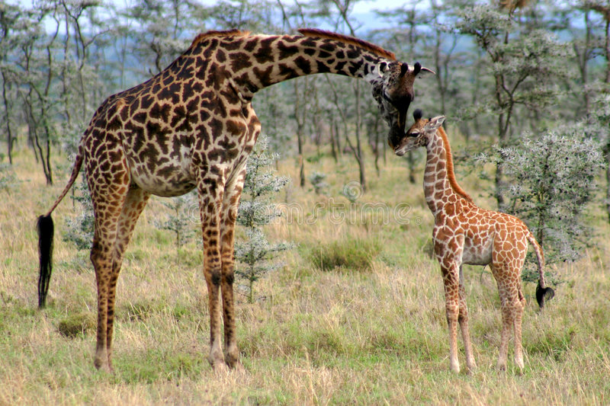

FOUR MAIN REASONS

Feeding
Giraffes can reach leaves, fruit, and flowers high up in trees. They can reach food that all other animals cannot, except the elephant.

Necking
Male giraffes have an elaborate ritual fight called ‘necking’ to establish dominance. They repeatedly swing their long neck to deliver powerful head-butts to their rival’s body and underbelly.

Lookout
The giraffe’s height helps it to keep a sharp lookout for predators across the wide expanse of the African savanna.

Structure
Surprisingly, even with its long neck, the giraffe has the same number of vertebrae in its neck as humans and other mammals. Giraffe have seven cervical vertebrae, like humans!

Source: GCF: Giraffe Conservation Foundation https://giraffeconservation.org/facts/why-do-giraffe-have-such-a-long-neck/

Now look at the nine words (or word pairs) in red letters above. These are special vocabulary words. Please write them in the space below. Then use your research tools to find the definition of each one

Vocabulary word Definition
- ___________________ _________________________
- ___________________ _________________________
- ___________________ _________________________
- ___________________ _________________________
- ___________________ _________________________
- ___________________ _________________________
- ___________________ _________________________
- ___________________ _________________________
- ___________________ _________________________

FOR VERY SPECIAL FUN, WATCH THE VIDEO BELOW. Do you think you can make a soap carving of an elephant?

https://www.youtube.com/watch?v=Y17RweezGi8

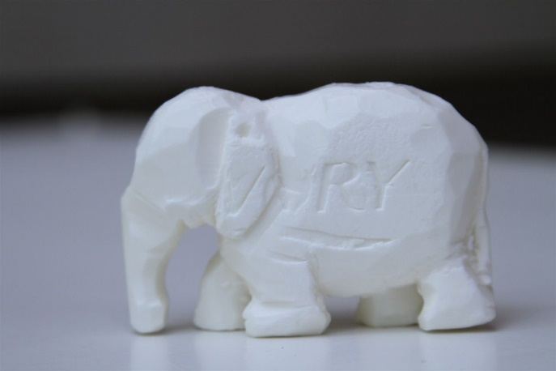
You only need 7 things: paper, scissors, plastic butter knife, small brush (to wipe away soap crumbs as you carve), pencil, paper clip, and bar of soap!

