Readers Theatre – Big Dog/Little Dog 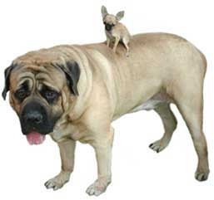

Little Dog: (In a high, excited voice) Hello!
Big Dog: (In a low, calm voice) Hello!
Little Dog: Did you see that bee?  Both: (Buzz) | 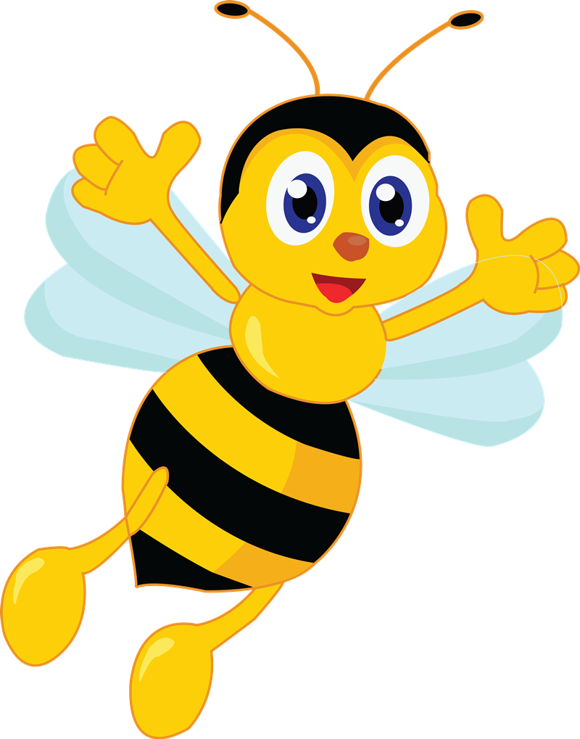
Big Dog: No, but I saw a bear. | 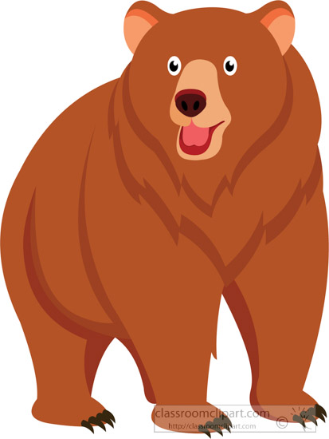
Little Dog: Did you see the cat?  Both: (Meow, Meow) | 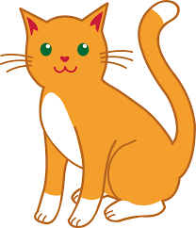
Big Dog: No, but I saw a cow. | 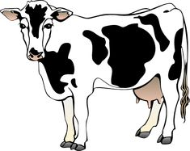
Little Dog: Did you see the duck?
Both: (quack, quack, quack)
Big Dog: No, but I saw the deer.  Both: Oh Dear! | 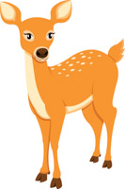
K-1 Readers’ Theatre
ABCs At the Zoo

Sound Effects & Gestures are in Italics
Child #1: Hello Friend!
Child #2: Hi There! Look at that Ant! | 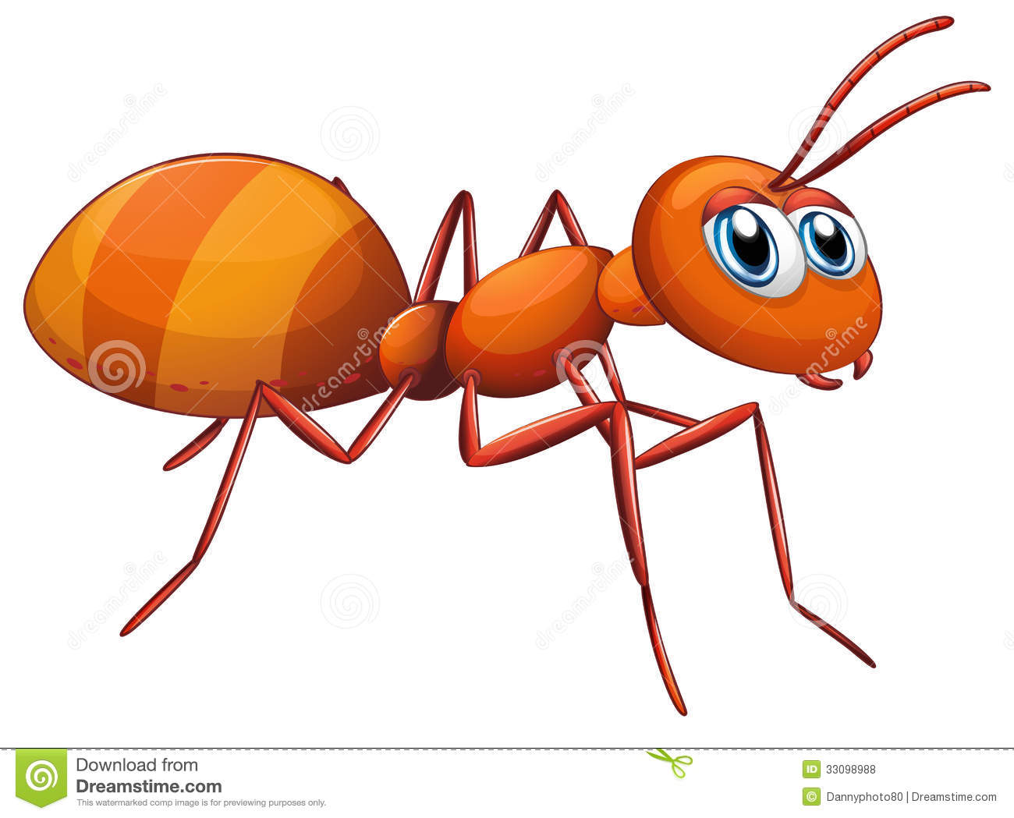
Both: EEww (E-U) (itchy motions)
Child #1: There’s a Bear (pointing) and a Bee
Child #2: A Bee and a Bear!
Both: Buzzzzz & Roar! (hands up!)
Child #1: There’s a Cat!
Child #2: With a Cow!
Both: MEOW!!! (giggle) MOO!!! (laugh out loud)

Child #1: That’s a little dog riding on a big one!
Child #2: (in a high tiny voice) Let’s Go!
Child #1: (in a low big voice) Okay! Okay!
Child #2: What about that deer!
Child #1: Look at that Duck.
Both: Quack! Quack! (Giggle)
Child #2: Chasing an Elephant!  Both: Gesture Elephant Trunk | 