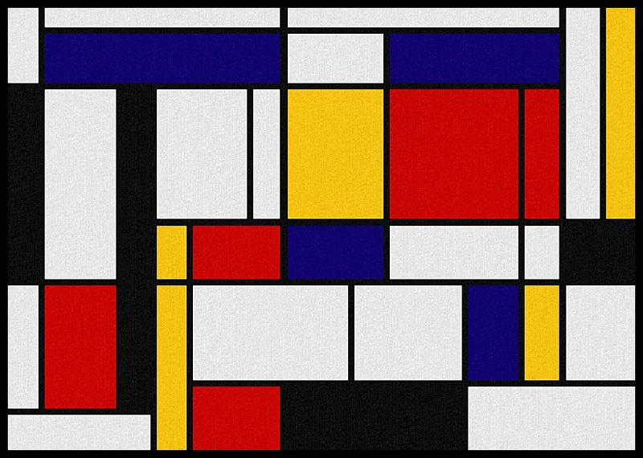

Actor #1
Actor #2
Actor #1
Actor #2
Actor #1
Actor #2
Actor #1
Actor #2
Actor #1
Actor #2
Actor #1
Actor #2
Actor #1
Actor #2
Actor #1
Actor #2

