Curriculum-Based Readers Theatre (based on the work of Rosalind Flynn)

Gestures & Sound Effects
- Allow people to communicate without making a sound – they can emphasize key words in the script
- Explore gestures: Come here, Good idea, What time is it?, No, I’ve got an idea, Be quiet, Bye, Call me
- Explore sound effects: Groan, Wind, Water, Truck Backing Up, Siren

Create your own:
- Identify the topic
  - NC.K.G.2 Correctly names squares, circles, triangles, rectangles, hexagons, cubes, cones, cylinders, and spheres regardless of their orientations or overall size.
  - K.E.1.2 Summarize daily weather conditions noting changes that occur from day to day and throughout the year
  - NC.1.MD.5 – Identify quarters, dimes, and nickels and relate their values to pennies
  - 1.L.1.3 – Summarize ways that humans protect their environment and/or improve conditions for the growth of the plants and animals that live there (e.g. reuse or recycle products to avoid littering).
- List info to include in the script (key academic concepts you want to reinforce)
- Consider possible setting & characters – for example:
Settings Characters
Awards Show Cheerleaders
Circus Detectives
Commercial Historical Figures
Evening News Reporter
Infomercial Superhero
Melodrama Tour Guide

- Write the opening lines – be creative and reveal the setting, context, and topic
- Decide where to add Gestures & Sound Effects
- Rehearse & Present
- Revise the First Draft
- Complete the Final Script

Resource: Dramatizing the Content with Curriculum-Based Readers Theater by Rosalind M. Flynn

TABLEAU
A group of models or motionless figures representing a scene from a story, an idea, or a concept from history.

Lion and Mouse – Illustrated by Jerry Pinkney
- RL.K.1 / RL.1.1 – Key Details in a text
- RL.K.9/ RL.1.9 – Compare & contrast adventures of characters in the story
- RF.K.5/RF.1.5 – accuracy & fluency to support comprehension
- W.K.3/W.1.3 – dictate/draw/write narrative in sequence with details
- SL.K.2/SL.1.2 – confirm understanding of key details in a text
- SL.K-5/SL.1.5 – add drawings to provide detail, clarify ideas, …feelings

Studying the images of the story – recreate in order – find a narrator

PANTOMIME/MONOLOGUE/DIALOGUE
- Pantomime a simple task – Gestures (Come here, Good idea, What time is it? No, I’ve got an idea, Be Quiet, Bye, Call me)
- Monologue – Weather Report
  - Science K.E.1.2 Summarize daily weather conditions noting changes that occur from day to day and throughout the year
  - Theatre Arts K.C.2.1 Use dramatic play to improvise stories and situations.
    - The children identify different types of weather and create a simple weather report to perform as a meteorologist and/or on-location reporter (e.g. during a storm). Use relevant weather vocabulary, along with any other phrases they may have heard when watching these at home. We also watched some examples of weather forecasts from Youtube.
- Dialogue – Read/Analyze the visual text - One-Minute Scripts
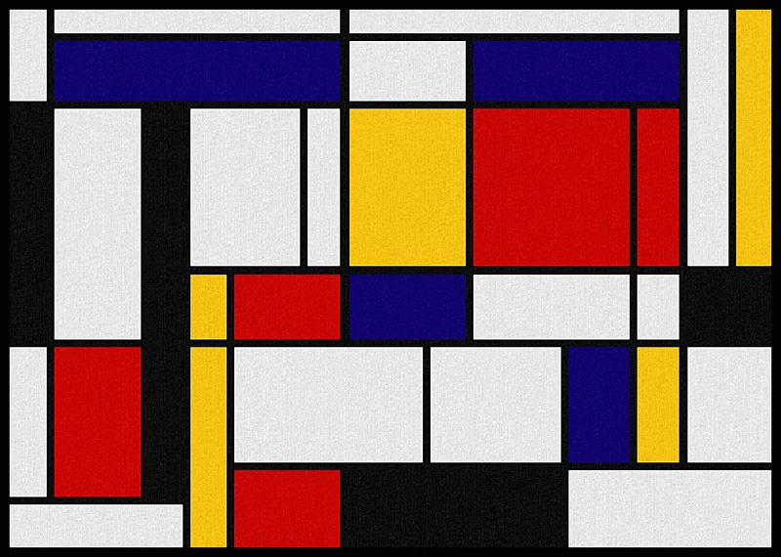
Individually - What do you see? Write on each line
- W.1.1 – Write opinion pieces – introduce topic – state an opinion – supply a reason
- SL.1.2 – Ask & answer questions about key details in a text … presented through other media
Readers Theatre Example – Awards Show
Cast
- Host (Narrator)
- Stage Manager – holds up applause sign, directs nominees where to stand
- Nominee #1 – an artist that uses recycled materials
- Nominee #2 – a gardener who uses composted materials
- Nominee #3 – a person who makes waterproof mats for the homeless out of plastic grocery bags
- Panel of Judges (3 people)
- Audience members – everyone else

Preshow: Musical Fanfare
Host: Welcome to the Regal Recyclers! An awards show dedicated to celebrating people in our community that make use of what others throw away.

Stage Manager: Holds up applause sign for audience

Host: Before we meet our three nominees, I would like to introduce our judges for tonight’s event. OR I will ask our three judges to introduce themselves …
(Judges can say who they are or the host can introduce depending on reading level)
Judge # 1 is the curator for modern work at the North Carolina Museum of Art – Artie McArt! (judge #1 stands and waves to the audience - stage manager holds up sign – audience applauds)
Judge # 2 is the head of waste management in our community – Waste NoMoore! (judge #2 stands and waves to the audience - stage manager holds up sign – audience applauds)
Judge # 3 is the manager at our local nursery – not where the babies cry but where you can buy all kinds of plants – Here is Elvia Greenthumbs! (judge #3 stands and waves to the audience - stage manager holds up sign – audience applauds)

Host: And now for our contestants. The rules of this competition are that each contestant gets 1 minute to make their case for why their recycling practices are the best for our environment. Before we start, let’s give a big round of applause for all our contestants and cheer them on.

Stage Manager: Holds up applause sign for audience

Host: Contestant # 1

Contestant #1: Steps forward and shares information that they have researched with a team of partners who are now in the audience. They talk about what they do and how it helps the environment – teacher should identify how much criteria (e.g. 3 ways it helps)…

Stage Manager: Holds up applause sign for audience

Host: Contestant #2

Contestant #2: Steps forward and shares information that they have researched with a team of partners who are now in the audience. They talk about what they do and how it helps the environment – teacher should identify how much criteria (e.g. 3 ways it helps)…

Stage Manager: Holds up applause sign for audience

Host: Contestant #3

Contestant #3: Steps forward and shares information that they have researched with a team of partners who are now in the audience. They talk about what they do and how it helps the environment – teacher should identify how much criteria (e.g. 3 ways it helps)…

Stage Manager: Holds up applause sign for audience

Host: Thank you contestants! While the judges confer on their scores, let’s have a little audience participation with a recycle echo chant – when I say “Recycling” you say “Saves the Earth”

Stage Manager: Holds up a sign that says “Saves the Earth!”

Host: leads chant for about 30 seconds while Judges confer – deciding on a winner and they are able to say why

Lead Judge(one chosen by the 3 to be spokesperson): Well, these were very hard decisions and it was even harder because in our real jobs we already cared about certain contestants but we put our biases aside and judged fairly. We award 3rd place to … because … (say something positive). 2nd place goes to … because … (another positive comment) and 1st place goes to … because … (the most compelling comment).

Stage Manager: Holds up applause sign for audience

Host: Well, that’s a wrap folks – thanks again for a great contest – we learned several ways we can save the earth!

Post-show: Musical Fanfare

NOTE
These kinds of scripts can be pre-written by the teacher with specific data points to be added by the students – at older grade levels, students can generate the scripts themselves.
Use this opportunity to highlight important vocabulary!
Remember – Readers’ Theatre is done with scripts in hand – can include props/costume pieces but those are not required – performers should read through enough times so they are comfortable adding their own characterizations – encourage them to be ‘dramatic

Subject: Grade: 1  ELA/Social-Emotional Learning  Theatre/Visual Art |  | Topic:  Mask Making and Character Traits
Teacher: Liz Droessler |  | Date: 8/9/18
NC Standard Course of Study Essential Standard:
RL.4 – Interpret words and phrases as they are used in a text and analyze how specific word choices shape meaning or tone.

NC Standard Course of Study Arts Essential Standard:
1.V.1 – Use the language of visual arts to communicate effectively.
1.C.2 – Use performance to communicate ideas and feelings.

NC Standard Course of Study Clarifying Objective:
RL.1.4 – Identify words and phrases in stories or poems that suggest feelings or appeal to the senses.

NC Standard Course of Study Arts Clarifying Objective:
1.V.1.2 – Create original art that expresses ideas, themes, and events
1.C.2.1 – Use improvisation to communicate activities in a variety of situations.
Content Vocabulary  Courage, Fiesta, Jaguar | Shared Vocabulary  Mask, Movement  Focus, Central Idea |  | Arts Vocabulary  Diction, Projection, Character,  Color, Shape
Assessment:  Fluency - Reading with expression, in phrases, at an appropriate rate  Comprehension – understands and interprets text accurately  Behavior – on-task, collaborative |  | Arts Assessment:  Visual Arts Theatre Arts  Met task criteria Met task criteria  Craftsmanship Diction/Projection  Creativity Characterization  Behavior Behavior
Multiple Intelligences/Mean of Representation/Action/Expression:
Intrapersonal – after reading the book, create a mask that represents your spirit animal
Bodily/Kinesthetic – create a movement response wearing the mask
Verbal-linguistic – write a monologue that represents what Nino is planning to say to his parents to convince them he is old enough to participate in the festival.

Background Information: Ninos Mask by Jeanette Winter
Although Niño wants to take part in the annual harvest fiesta and wear the special mask needed in
order to catch the jaguar, his parents think he is too young to take on such a risky task, but Niño is determined and so secretly makes his own special mask in the hopes of getting his chance at the fiesta.
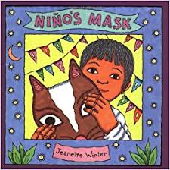
Activity |  | Materials and Time
Focus and Review (Establish prior knowledge)  DOK  Recall | Wearing an animal mask as a demonstration and using appropriate animal voices/gestures ask students what they know about a harvest fiesta where people might wear costumes or masks – perhaps a follow-the-leader movement energizer | Animal mask  Book  3 minutes
Statement  (Inform students of objective)  DOK  Strategic Thinking | Today we’re going to read a book about a young boy who demonstrates courage in pursuit of his dreams.  We’ll also build and use masks to interpret the book and share our own insights. | 2 minutes
Teacher Input (Present tasks, information, and guidance)  DOK  Skills & Concepts | Do a picture walk of the book – ask prediction questions.  Read the book – highlighting key details and vocabulary. Share ideas for how to interpret. Use your imagination to be something larger than yourself.  Lead students through interpretive movements and have them contribute to a word wall.  Clarify instructions about creating original characterizations based on Nino’s journey. | 30 minutes

Guided Practice (Elicit performance provide assessment and feedback)  DOK  Strategic thinking/reasoning | Encourage students to go beyond their comfort zone as they create their own mask character. Discuss scoring rubrics.  Talk about the critique/feedback process. | 15-20 minutes
Independent Practice Seatwork and Homework (retention and transfer)  DOK  Extended Thinking | Students create an animal mask and improvise appropriate movements to share at the fiesta.  Circulate to ensure students are on task.  Provide opportunities for rehearsal with coaching  Provide time and support for the MI choices listed above.  On a second day encourage students to share their monologue/movement/mask Audience demonstrates appropriate etiquette and constructive feedback. Students complete self-reflections. | Mask-materials  Musical underscore  30 minutes – day 1  30 minutes – day 2  Video record performances
Closure (Plan for Extended Thinking maintenance)  DOK  Extended Thinking | Discuss process – changes for the future | 10 minutes

