Make a list of things you notice on Nick Cave’s Soundsuit at Weatherspoon Art Museum.

Here are some images of other kinds of Soundsuits by the artist Nick Cave:

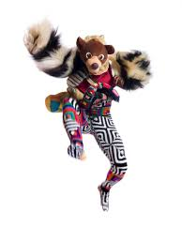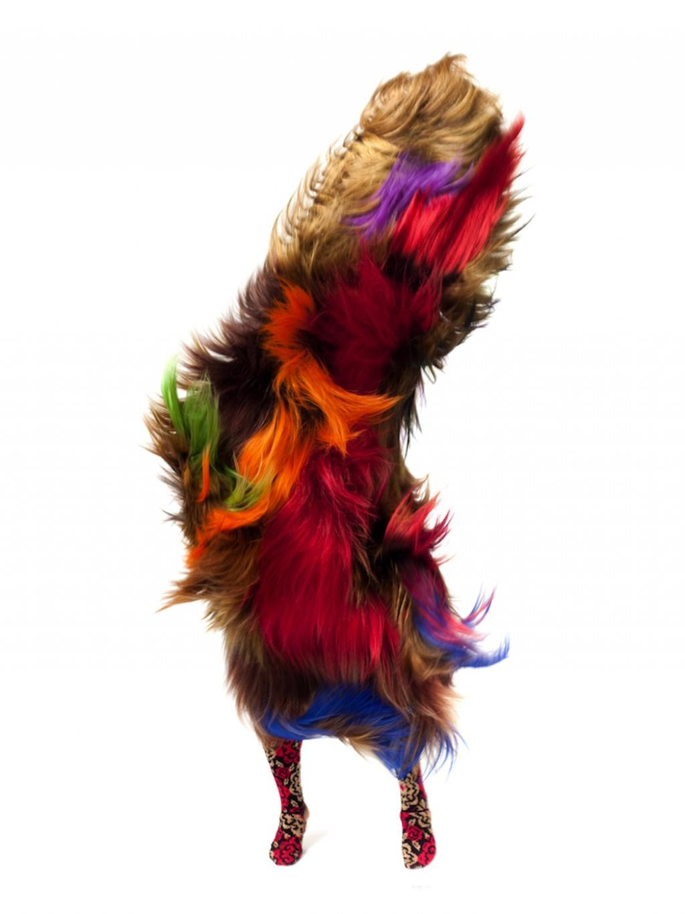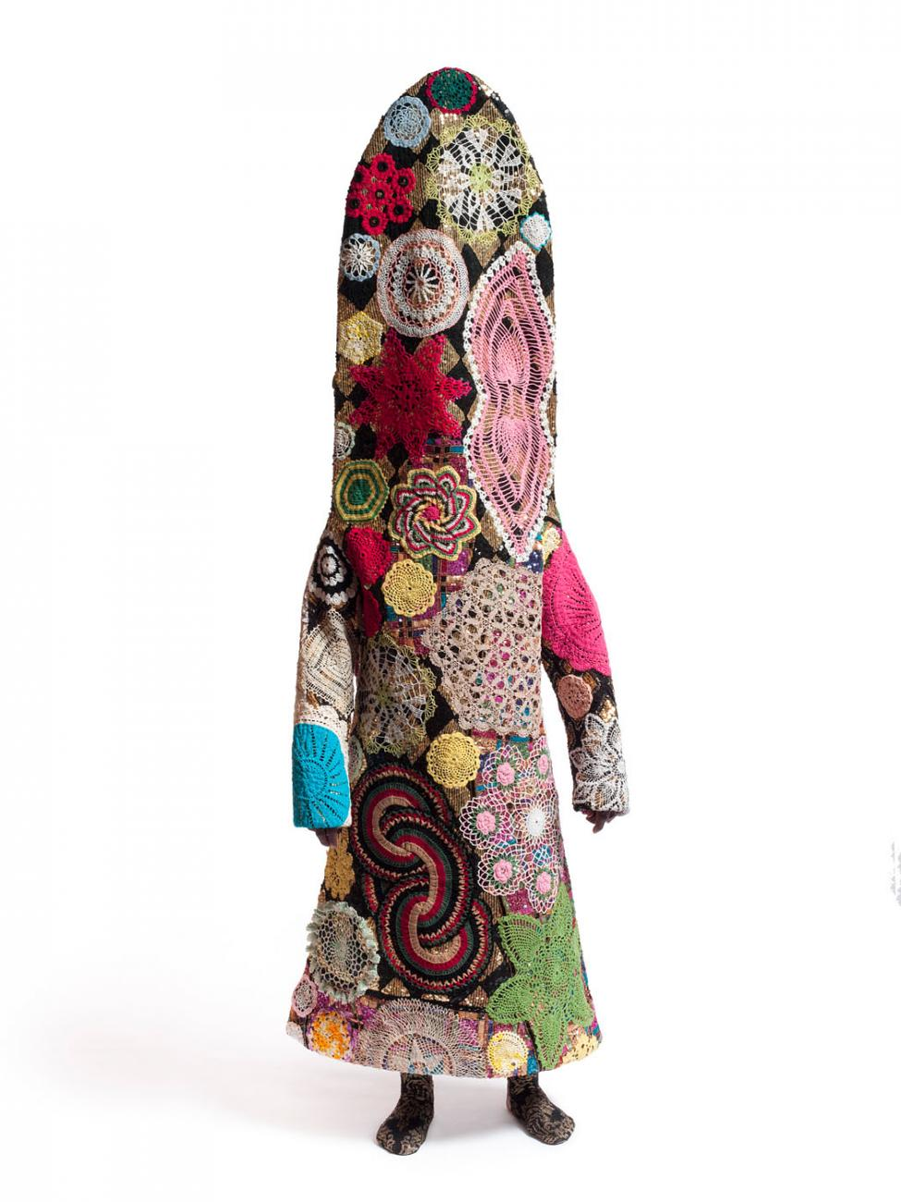

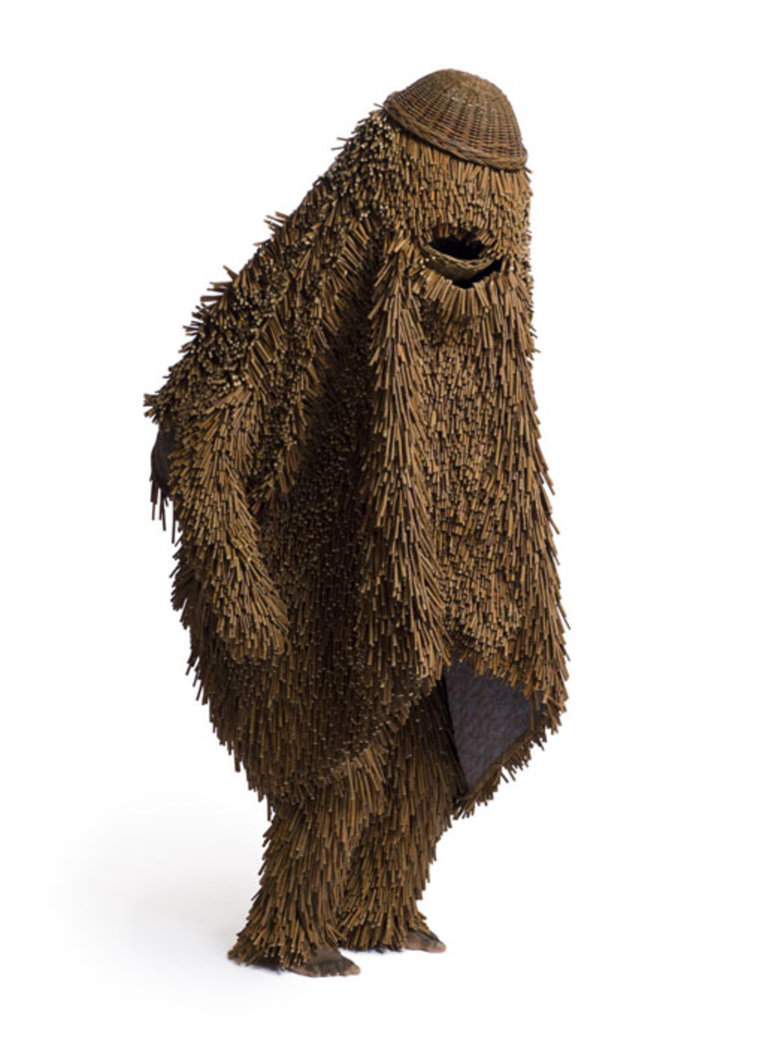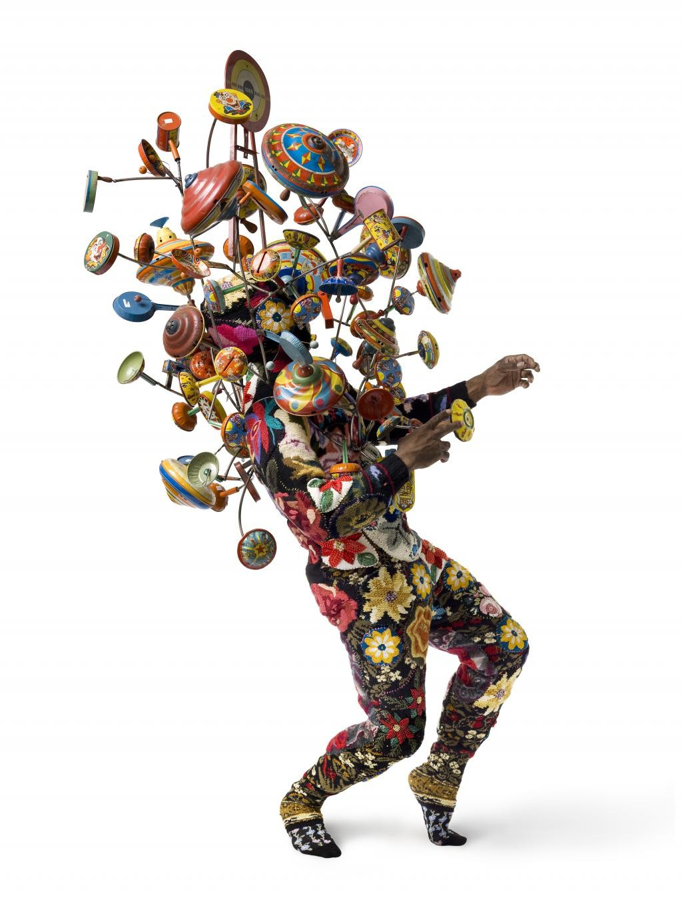

On this page, design your own sound suit. What shapes, lines, colors, and objects will you include?

