GCS AIA Integrated Lesson Plan
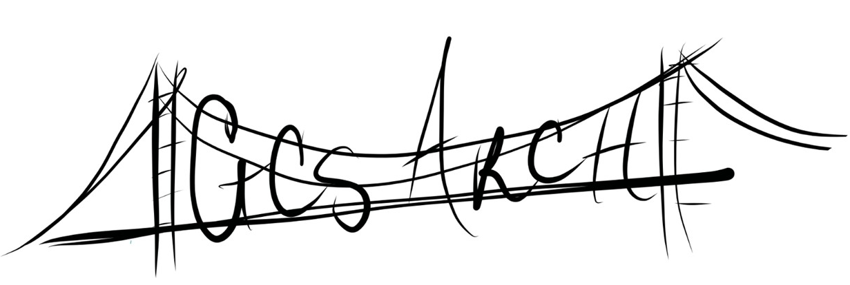

Arts Raising Children Higher
GCS Arts Integration Academy
Subject: Science/ELA/Dance Grade: kindergarten | Topic: Fives Senses
Teacher: Melinda Waegerle  With collaborator Michelle Childress  Hunter Elementary | Date: Fall of 2018

NC Standard Course of Study Essential Standard:
K.E.1 Understand change and observable patterns of weather that occur from day to day and throughout the year.
RI.1.2 Identify the main topic and retell key details of a text.

NC Standard Course of Study Arts Essential Standard:
K.CP.1 Use choreographic principles, structures, and processes to create dances that communicate ideas, experiences, feelings, and images.

NC Standard Course of Study Clarifying Objective:
. K.E.1.1 Infer that change is something that happens to many things in the environment based on observations made using one or more of their senses

NC Standard Course of Study Arts Clarifying Objective
K.CP.1.4 Create dance movement to represent words, ideas, experiences, and feelings.
K.CP.2.1 Understand how to control body and voice in personal and general space.

Content Vocabulary:  Five senses: sight, smell, hearing, taste, and touch  Fall, retell | Shared Vocabulary:  sight, smell, hearing, taste, and touch  Fall, retell, repeat |  | Arts Vocabulary:  Voice, body, space, respect, see, smell, hear, taste, touch, zip, follow, curve, pop, fall, crunch , travel, tell/retell, repeat
Assessment: type  Pre-Assessment: Q & A what have you noticed about the weather today? Are you noticing changes? What season of the year is it?  Formative: students embody movement suggestions through improvisation, able to give a dancer answer  Summative: able to dance poem with ease that expresses the meaning and intent of the text and use dance controls |  | Arts Assessment:  Pre-Assessment: Q & A what have you noticed about the weather today? Are you noticing changes? What season of the year is it?  Formative: students embody movement suggestions through improvisation, able to give a dancer answer  Summative: able to create and dance a poem with ease that expresses the meaning and intent of the text and use dance controls
Multiple Intelligences/Means of Representation/Action/Expression:
Kinesthetic – movement expression Linguistic- embodies words with clarity Naturalist – connections to weather and five senses Visual- uses visual cues to support learning

Activity |  | Materials and Time  Corn, pumpkin, leaves, soup pan, jacket and some leaves.
I. Focus and Review (Establish prior knowledge) | Introductions  Use of controls in order to do best work. Voice, Body, Space and Respect.  Leads into a warm-up using some foreshadowed vocabulary | _5___minutes
II. Statement (Inform student of objectives) | Discourse based on critical thinking: something different is happening with the weather, what did you notice? Do you know the season we are now in…summer is over and now it is Fall? We are going to create a dance today about Fall and our five senses. | ___3_ minutes
III. Teacher Input (Present tasks, information, and guidance) | Senses are the way our body understands. We use our  Nose to ______  Tongue to_______  Eyes to ________  Ears to _________  Our skin to________  Touch and isolate body part. | ___1_ minutes
IV. Guided Practice (Elicit performance, provide assessment and feedback) | Use poem below.  Have students improvise and select movements that embody the chorus phrase.  Explore each sense through guided improvisation.  Skin/touch- shiver, dance jacket  Smell/ - follow your nose to new spot in space  Tongue/ taste- becomes whole body  Eyes/see- use dance shapes with pumpkin, corn and leaves  Ear/hear- honk, crunch  Check by circling back, verbal cues, students dance, teacher observes and provides feedback…I see… | _14___ minutes
V. Independent Practice -- Seatwork and Homework (Retention and transfer) | Break class in half to perform for each other.  Controls, best dance moves, show dancing words. End and begin with still pose. Applaud  What was something you noticed about the performance? What seemed extra special | _5___minutes
VI. Closure (Plan for maintenance) | What was our dance about today? What are our five senses>can you give me a dancer answer? | __2__minutes

Arts Integration is and approach to teaching in which students construct and demonstrate understanding through and with an art from. Students engage in creative process which connects an art form and another subject area and meets evolving objective in both.
The Kennedy Arts Center

Self- Check for integration “A truly integrated lesson or unit has learning targets from both content areas (arts and non-arts), instruction in both areas, and assessment in both areas.”

See poem on page 2.

It’s Getting to be Fall
And I Know
Because My Five Senses Tell Me So.

By Melinda S. Waegerle

It’s getting to be Fall and I know because my five senses tell me so!

I am feeling with my skin: a change in temperature. I need a jacket to wear outside. Zip it up or button too.

It’s getting to be Fall and I know because my five senses tell me so!

I am smelling with my nose: hot soup and other food that cooler weather brings. My nose sniffs and follows the scent.

It’s getting to be Fall and I know because my five senses tell me so!

I am tasting with my tongue: pumpkin spice doughnuts and maybe Fall candy so sweet candy corn and…

It’s getting to be Fall and I know because my five senses tell me so!

I am seeing with my eyes: a change in what I see at the grocery…pumpkins, Indian corn and the trees leaves are changing color as they flutter to the ground.

It’s getting to be Fall and I know because my five senses tell me so!

I am hearing with my ears: honking of birds traveling, crisp leaves under my feet

It’s getting to be Fall and I know because my five senses tell me so!

