GCS AIA Integrated Lesson Plan
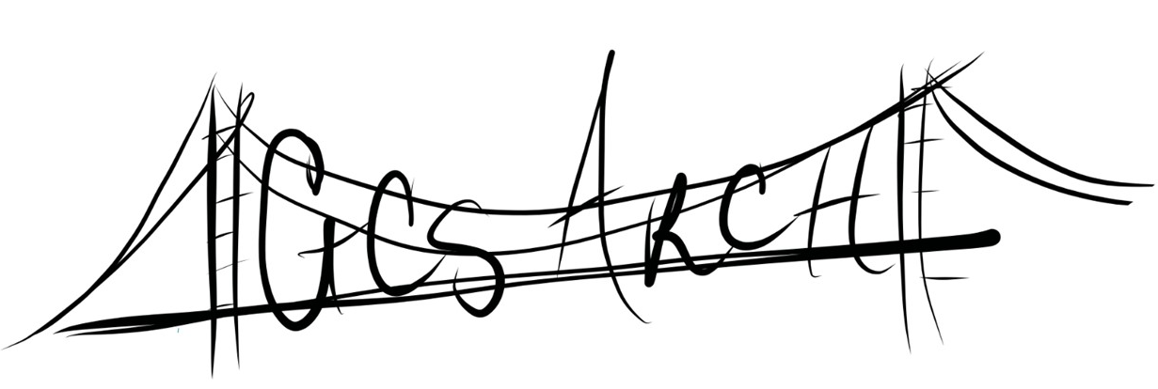

Subject: ELA Grade: K | Topic: Farms/The Little Red Hen
Teacher: Kindergarten Team at Jefferson | Date:

NC Standard Course of Study Essential Standard:
RL.K.2 - With prompting and support, retell familiar stories, including key details.

NC Standard Course of Study Arts Essential Standard:
K.C.2 - Use performance to communicate ideas and feelings.

NC Standard Course of Study Clarifying Objective:
RL.K.2- With prompting and support, retell familiar stories including key details.

NC Standard Course of Study Arts Clarifying Objective
K.C.2.2- Use dramatic play to re-enact text read aloud.

Content Vocabulary:  retell, beginning, middle, end, fiction | Shared Vocabulary:  recall |  | Arts Vocabulary:  re-enact, recall, feelings
Assessment:  - Pre-Assessment- Q & A  - Formative Assessment- Select students to use mask to become characters and put themselves in order they appear in story.  - Summative Assessment- Cut and glue retell activity |  | Arts Assessment:  Retell the story through dramatic play.
Multiple Intelligences/Means of Representation/Action/Expression:
- Bodily-Kinesthetic
- Verbal-linguistic

Activity |  | Materials and Time
I. Focus and Review (Establish prior knowledge) | Today we are going to talk about/review how to retell a story. Who remembers what a good retell looks like and sounds like? | - Retell “High 5” anchor chart  __5__minutes
II. Statement (Inform student of objectives) | Today we are going to listen to the story The Little Red Hen. (see CKLA Farms- Purpose for Listening- Read)  Think about what we discussed about retell. | - CKLA Manual  - Retell “High 5” anchor chart  __3__ minutes
III. Teacher Input (Present tasks, information, and guidance) | We are going to act out the story, after we read it aloud. This will help us practice “retell”. | __1__ minute
IV. Guided Practice (Elicit performance, provide assessment and feedback) | After reading the story, students will take turns using character mask and retelling the story in order. They will act out and use expressions with their speaking parts to add excitement in the presentation. | - CKLA Manual  - Character mask  __20__ minutes
V. Independent Practice -- Seatwork and Homework (Retention and transfer) | Students will return to their seats and complete a retell cut, color, and glue activity sheet. | - Retell cut, color, and glue sheet  __10__minutes
VI. Closure (Plan for maintenance) | What was our focus today?  What does a good retell look like and sound like? | - Retell “High 5” anchor chart  __6__minutes

Arts Integration is and approach to teaching in which students construct and demonstrate understanding through and with an art from. Students engage in creative process which connects an art form and another subject area and meets evolving objective in both.
The Kennedy Arts Center

Self- Check for integration “A truly integrated lesson or unit has learning targets from both content areas (arts and non-arts), instruction in both areas, and assessment in both areas.”

