 

**How Can Parents Create an Account in Canvas?**

**Step 1**

To begin, creating a parent account in Canvas you will need to launch **Google Chrome**

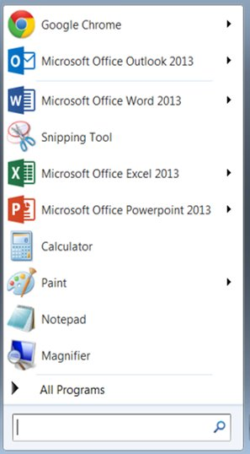

**Step 2**

Type in the following URL address in the address bar: <https://gcs.instructure.com/login/canvas>

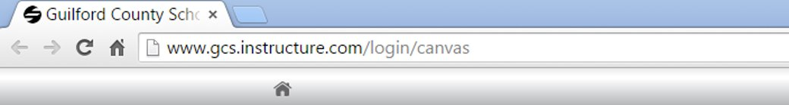

**Step 3**

A Canvas login screen window will appear. Click on the Parent of a Canvas User? Click Here for an **Account link**. ​

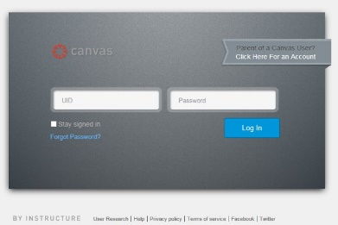

**Step 4**

A parent signup window will appear. You will need to complete all fields (your name, your email, child’s username (student number), child’s password (birthdate – MMDDYYYY), and check the box that you agree to the terms of use and acknowledge the privacy policy. **Click on the Start Participating button**

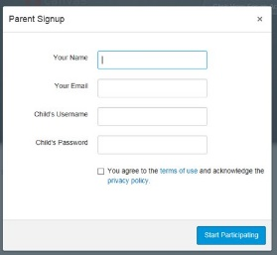

**Step 5**

You will then see a Welcome to Canvas! message. Your account is almost set up. To finish, please check your email at the email address you registered and **get started**. Note: You will need to set a password before you can log back

